TEST RESULTS FOR CUSTOMER CHURN PREDICTION

Overall Customer churn distribution

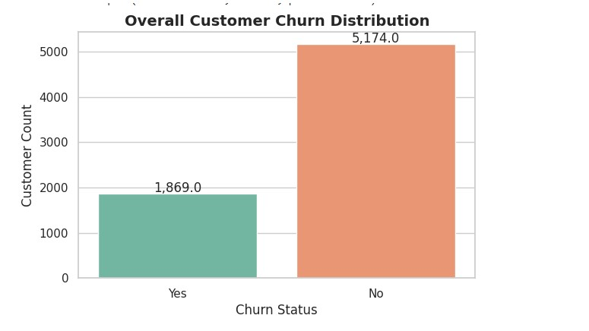
Light GBM & Shap values

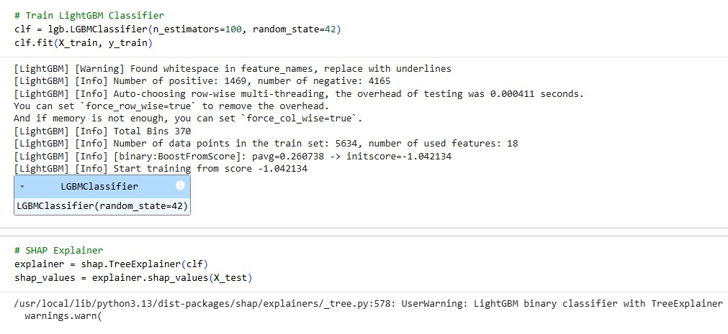

Kaplan Meier Estimator and Cox Proportional Hazards Model

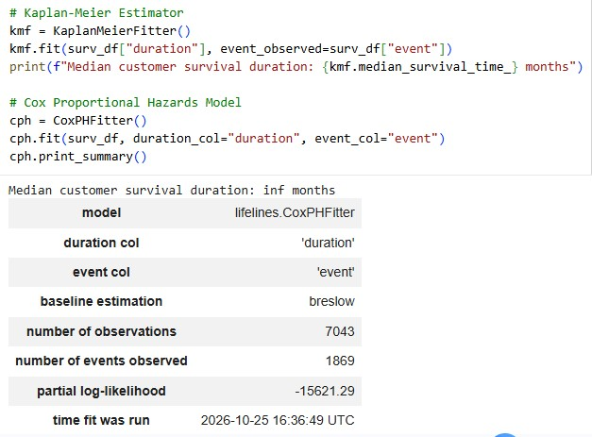
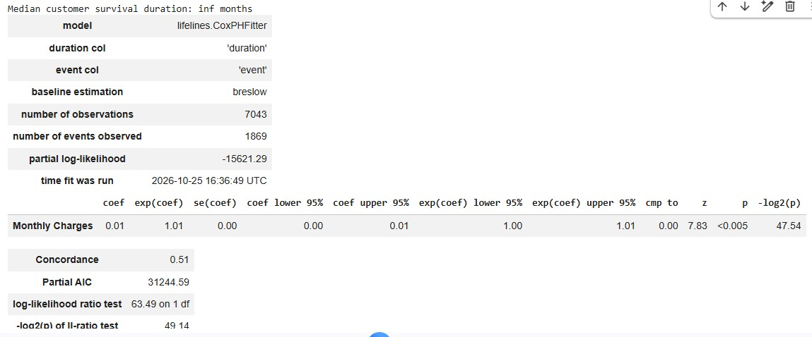

Customer Lifetime Value & Clustering

